Reviewer’s question：Another question is that the authors claim, by calculation, that the gap distance between feed and permeate in NG membrane is exponentially related with temperature (35 nm @ 45 oC, > 2 µm @ 80 oC). If this is true, the gap distance could be observed using OCT technique (higher temperature might be used if OCT resolution is limited). I suggest authors conduct such experiment to prove this calculation.

Response:我们通过计算得到理论距离是1325 nm，即如何利用OCT技术证明冷水和热水之间有个1-2微米的气体间隙（air gap），也就憎水膜的厚度为1-2微米，来验证我们计算。（提供OCT图片证明，设备示意图片和实际设备图等等）

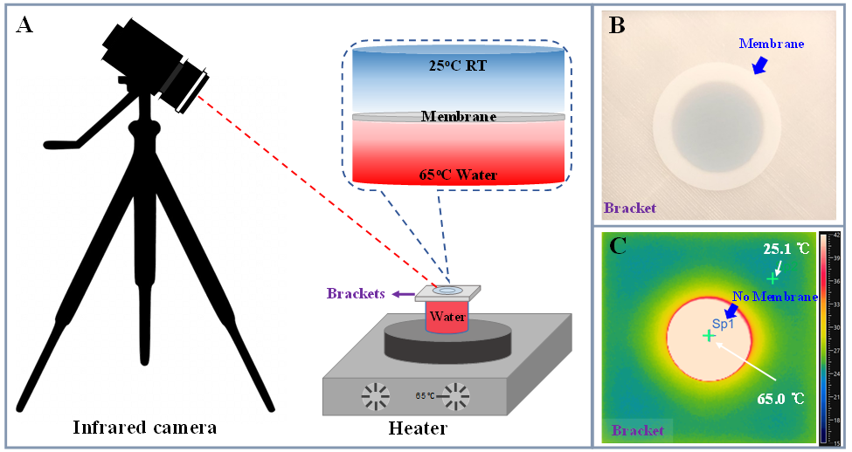

以下信息供你参考：

（直接接触式膜蒸馏）DCMD： *DCMD is a membrane distillation (MD) configuration in which both solutions, feed and permeate, are in a direct contact with a hydrophobic porous membrane. Thus, the water vapor transferred across the membrane is directly condensed in a cold permeate inside the membrane module.*

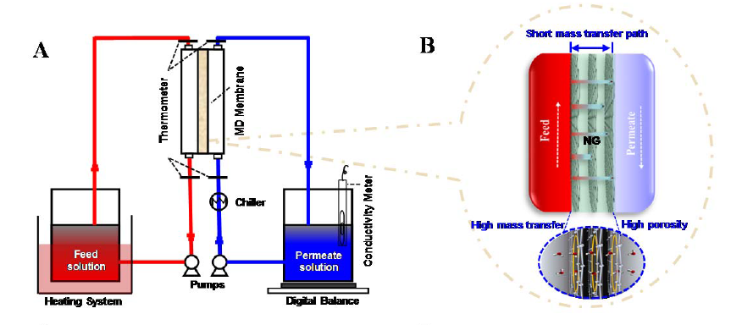

死端过滤装置红外热成像和实际膜组件

